# PeopleSafe - No Access to this Beneficiary/Colleague or Member Search Returns Error (Account is Only Accessible to Those Dedicated to the Client)

Pop Up – No Access to Beneficiary

Member Search Returns Error - Account is Only Accessible to Those Dedicated to the Client

Related Documents

**Description:** Instructions on how to respond to a member, colleague or caller when you are unable to access an account.

|  |
| --- |
| Pop Up – No Access to Beneficiary |

**Example:** Pop-up for Dedicated Team for CVS Employee Colleagues.

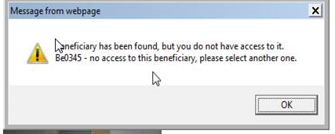

No support can be provided.

If you receive this message ask the member  Are you, or are you calling for a CVS Health Employee?

**CCR:** If yes, warm transfer and properly introducethe caller to Customer Care for Our CVS Health Colleagues at **1-866-284-9226** (**Monday thru Saturday:**7 am to 9 pm CT **Sunday:**8 am to 4 pm CT) **or**

**1-800-558-0860, opt. 1** (Aetna One Advocate/Precert/Rx).

Suggested verbiage for transfer:

Icon - Conversation We have a specialized team that can assist you.  May I give you the direct toll-free number for your future use?  Thank you!  I will connect you with your dedicated team now so they can assist you further. It may take me a few minutes to reach them - would you prefer to hold until I reach them, or would you prefer that I check back with you every few minutes?

Top of the Document

|  |
| --- |
| Member Search Returns Error - Account is Only Accessible to Those Dedicated to the Client |

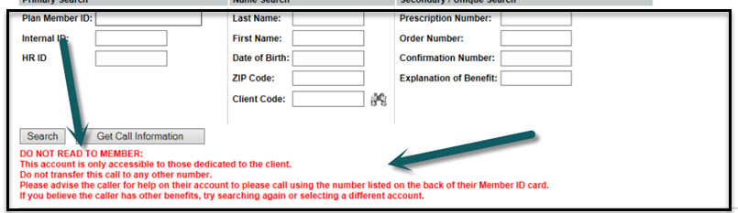

Perform the following steps:

|  |  |  |  |
| --- | --- | --- | --- |
| **Step** | **Action** | | |
| **1** | Perform a Name and Date of Birth Search  Do **not** add a space or an underline prior to the first letter of either name or the system displays an error.   * If a pop-up message displays and states “Beneficiaries were found, but none matched your filter criteria. Refine your criteria, select “**Inactive or All**.” and search again. | | |
| **If the member’s information…** | **Then…** | |
| Displays | Continue with the call. | |
| Does **NOT** display | Determine if a Specialty Medication: The caller is not required to have active coverage with us.  Determine if a Specialty medication and if so, warm transfer to Specialty.  **Exception:** If the client is Carefirst, warm transfer to Specialty per the number in the Carefirst CIF (**1-855-264-3237**).  Let me get you over to our Specialty pharmacy, who directs you to your correct therapy for further assistance.   * If not, review the lower left corner of the screen for messages in red font. | |
| **If error message indicates…** | **Then…** |
| DO NOT READ TO MEMBER | I apologize but your benefits are not serviced by us. Please call the Customer Care number listed on the back of your prescription benefits card.  If you do not have your Prescription Benefits card, you will need to contact your Benefits provider or Insurance company.       * Do **not** transfer these calls or attempt to further help the caller. * If a 3rd party caller, (who does not have access to ID card) advise them to contact member to obtain specific number from ID that they can then use to get assistance with account. * For overnight Help Desk, have the pharmacy or member call back during regular business hours. * This client specifically requested that searches could not be performed by our CCR’s. |

Top of the Document

|  |
| --- |
| Related Documents |

[Log Activity and Capture Activity Codes (005164)](https://thesource.cvshealth.com/nuxeo/thesource/" \l "!/view?docid=bdac0c67-5fee-47ba-a3aa-aab84900cf78)

[Customer Care Abbreviations, Definitions, and Terms](https://thesource.cvshealth.com/nuxeo/thesource/#!/view?docid=c1f1028b-e42c-4b4f-a4cf-cc0b42c91606) (017428)

**Parent Document:** [CALL 0049 Customer Care Internal and External Call Handling](https://policy.corp.cvscaremark.com/pnp/faces/DocRenderer?documentId=CALL-0049)

Top of the Document

Not to Be Reproduced or Disclosed to Others without Prior Written Approval

**ELECTRONIC DATA = OFFICIAL VERSION / PAPER COPY = INFORMATIONAL ONLY**